Problem 41: Arc Measure

Time Limit: 1 second

Coach Academy teaches students to think, create and code. One day the instructor gave the students this interesting problem.

If you were given one of these students, would you be able to solve it?

Given a set of *N* points on the circumference of a *2D* circle centered at the origin, where the *ith* point is located at ai degrees from the *+ve x-axis*.

You need to find the minimum integer arc measure *M*, such that you can cover all the points using no more that *K* arcs of measure *M*. The arc covering must be contiguous with no gaps.

It is ok for two or more arcs to overlap.

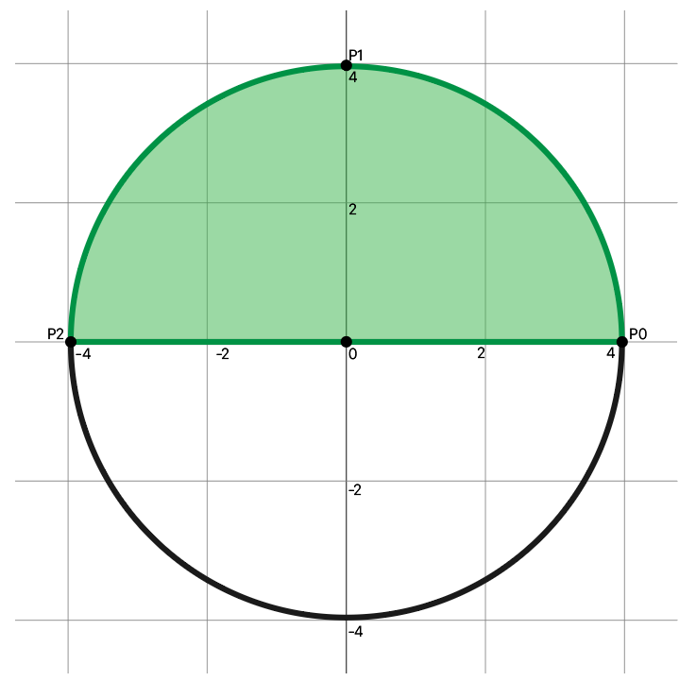

**Input**

First line will be the number of test cases *T*, in each test case you will be given the following:

First line will have 2 integers *N* and *K* separated by a space. ($1≤N,K,≤360$)

Followed by a line containing *N* integers separated by a space, each integer. ($0≤A_{i}≤359$)

**Output**

For each test case, output one number in a line by itself, *M* the minimum arc measure.

|  |  |
| --- | --- |
| **Sample Input 1** | **Sample Output 1** |
| 1  3 1  0 90 180 | 180 |

**Note**

An arc measure is the number of degrees it can cover from the circumference. For example, an arc measure of 90 covers quarter of the circle.